Connect Raspberry Pi 5 (RPI) to new WIFI network

Temporary configuration of Windows laptop
Your laptop needs to be configured with a manual IP address to be able to connect to the RPI.
- Open "Control Panel" > "Network and Internet" > "Network Connections"
- Double-click on "Ethernet". This should open a pop-up window called "Ethernet Status".
- Click on "Properties", search for and double-click on “Internet Protocol Version 4 (TCP/IPv4). In the pop-up window that opens, fill in the following information:

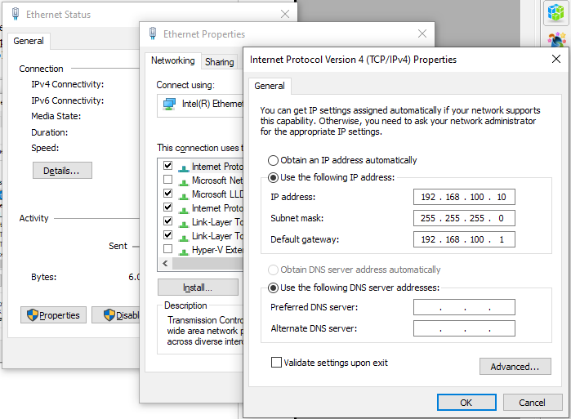
- Click Ok. NB: The laptop will now be disconnected from the internet until we finish.

Establish SSH connection to RPI
The RPI is configured with
- eth0 (LAN): IP 192.168.100.1
- user: admin
- password: jambo-bomet

- Write down the name (SSID) of your WIFI.
- Connect the laptop and the RPI with a LAN cable.
- Press the Windows key and type “CMD” into the the search bar. This should open a terminal. Type in “ipconfig” and compare the information to the one shown in the screenshot. You should see something like the last 5 lines.

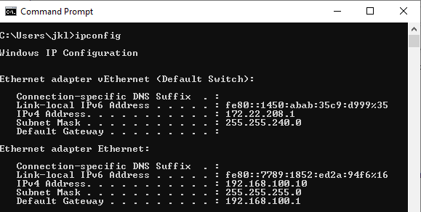
- Now type “SSH admin@192.168.100.1” at the prompt. You should see something like this:
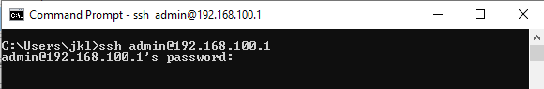
- Enter the password for user admin: “jambo-bomet” and hit Enter. You should then see something like this:
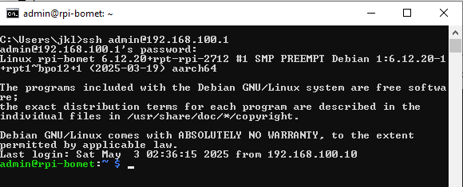

- At the prompt, type “sudo nmtui”. This will open an interface like this:
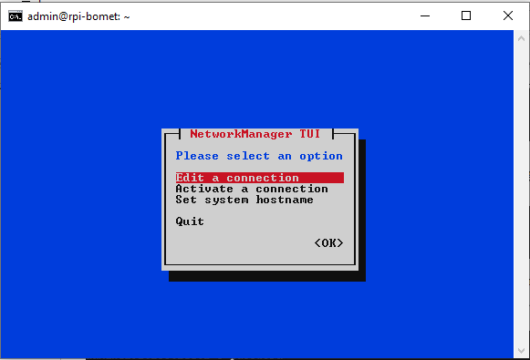
- Using the arrow keys on your keypoard, select the “ILRI ...” entry and move over to “Delete”, then hit “Enter”. Another pop-up will open up. Move to “Delete” and hit “Enter”. The ILRI wi-fi should now be gone.
- Select “preconfigured” and move over to “Add”. Hit Enter.
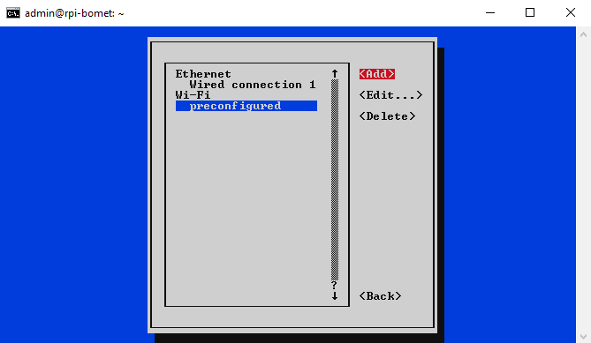

- Select “Wi-Fi” and move to “Create”, then hit “Enter”.
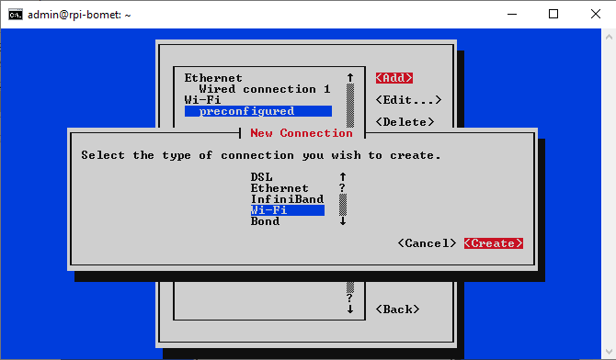
- In the dialogue that opens up, move to “Profile name” and enter something meaningful, e.g. “Bomet University College”. Then move to SSID and type the name of your wifi (cf. Point 1 above). Then move to Security “None”, hit “Enter”, and select the right Security, probably “WPA & WPA2 Personal”. Then enter the Password for your Wi-Fi. You may want to activate “(X) Show the password” (toggle with spacebar)
Make sure the options
(X) Automatically connect
(X) Available to all users
are selected (toggle with the spacebar).
Then move down to the bottom of the dialogue to “Ok” and hit “Enter”.
NB: In my case here in the hotel, I used “Profile name” “Hotel”, and I don't need a password, so I select Security “None”.
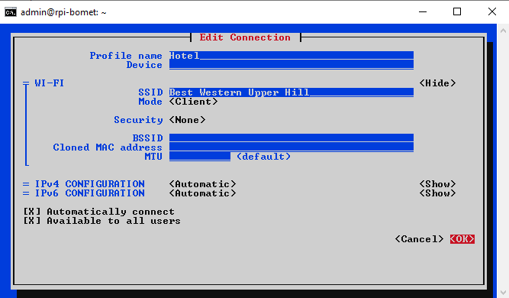
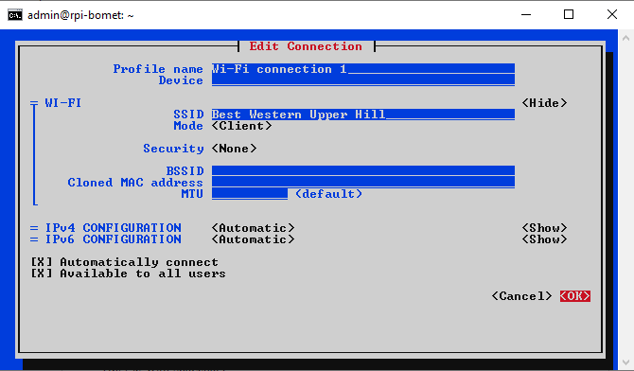
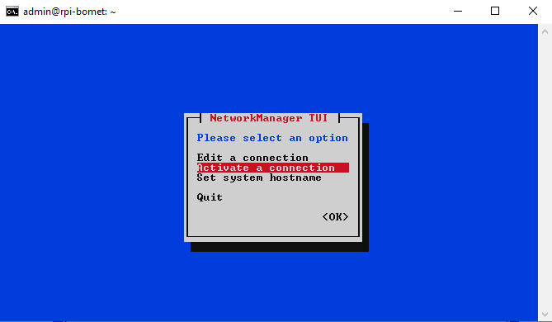
- Then move to “Back” and hit “Enter”. Then move to “Activate a connection” and hit “Enter”

- Move to the connection you have created (in my case “Hotel”. If you see “Deactivate” on the right side, then everything is fine. If you see “activate” on the right side, then move there and hit “Enter”. Finally, go “Back” and “Quit”.

- Back to the green prompt, type “ifconfig” and hit “Enter. Look for wlan0 and write down the information for inet (in my case 172.16.1.178).
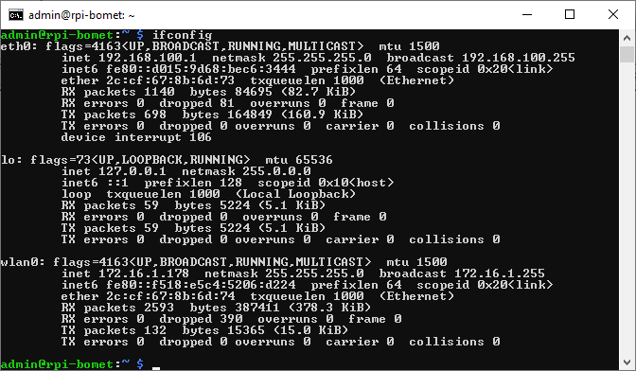
- Type “exit”. This takes you back to the Windows CLI, Type “ping <the inet address from above>”. You should see something like this:
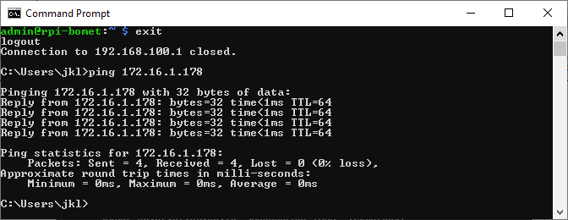
If you see this, your RPI is connected to your Wi-Fi. SUCCESS!!

- Unplug the LAN cable from the RPI and your laptop.
- Open “Control Panel” again and find the networking dialogue (cf. Above). Then select “Obtain an IP address automatically”. Your laptop will be back to normal.
